Name: Juliette Joseph-Odogbo
Course: Linux Administration.
Date:9/25/2025
Assignment: The Grep Family.
- Print all lines containing the string Lane
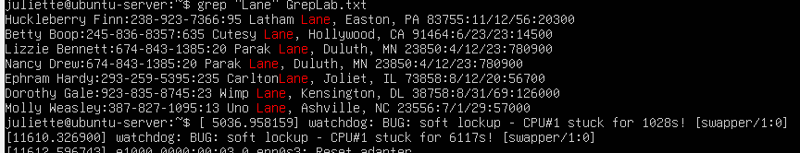
grep "Lane" SedLab.txt
How & Why (student-friendly):
- grep → searches the file line by line to find matches.
- "Lane" → tells grep to look for the exact text “Lane” anywhere in the line.
- GrepLab.txt → the file being searched.
Why it works:
- Grep goes through each line and prints only the lines that contain the word, Lane.
- This ensures you see all occurrences of Lane, whether it’s a first name, last name, or part of an address.

- Print all lines where the person’s first name starts with H
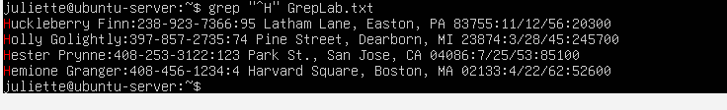
grep "^H" GrepLab.txt.
Explanation (piece by piece):
- grep → searches the file line by line for matches.
- ^ → line starter, meaning grep only looks at the very first character of the line.
- H → specifies that the first name must start with H.
- GrepLab.txt → the file being searched.
Why it works:
- Grep looks at the first letter of each line using the start-of-line marker (^)
- In this case, the first letter we want is H, so it prints out all lines where the first name begins with H.

- Print all lines ending in three zeros (000)
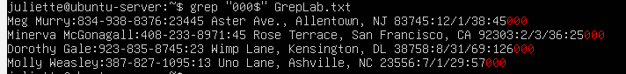
grep "000$" GrepLab.txt
Explanation (piece by piece):
- grep → searches the file line by line to find matches.
- "000" → looks for exactly three zeros in a row.
- $ → a line-end marker, meaning grep only matches this pattern if it appears at the very end of the line.
- GrepLab.txt → the file being searched.
Why it works (Question 3):
- Grep looks for lines where the text ends with three zeros.
- The $ shows that the three zeros are at the very end.
- This makes sure grep prints only the entries finishing with 000, not zeros in the middle of the text.

- Print all lines that do not contain 408.
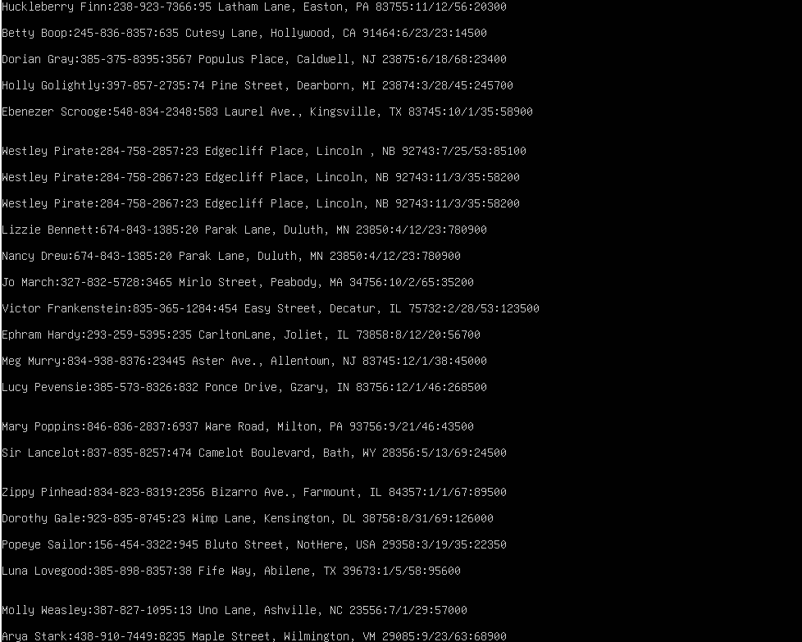
grep -v "408" GrepLab.txt
How this command works
- grep → goes through the file one line at a time to check the text.
- -v → tells grep to show everything except what we do not want.
- "408" → the text we do not want to see
- GrepLab.txt → the file we are searching.
Why it works (Question 4):
- Grep only prints lines that do not contain 408 because of the -v option.
- The -v tells grep to show everything except what we do not want, so any line with 408 is skipped.

- Print all lines where birthdays are in the year 1935 (be careful of the date for MM/DD/YY).
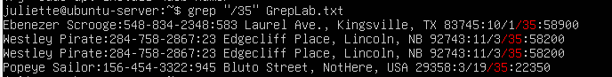
grep "/35$" GrepLab.txt
How this command works
- grep → looks through the file one line at a time.
- "/" → checks for the slash that separates the day from the year.
- 35 → matches the year 1935 we are looking for.
- $ → makes sure grep only finds birthdays that end with 35, not any other 35 in the line.
- GrepLab.txt → the file we are checking.
Why it works:
- Grep goes through each line and focuses on the part of the birthday after the slash, which is the year.
- The / ensures grep looks at the year section.
- 35 selects only birthdays from 1935.
- $ makes sure grep only picks birthdays ending with 35, so other numbers in the line are not included.
- Together, this prints just the birthdays in 1935, exactly what we want.

- Print all lines where the phone number is in an area code that starts with an 8
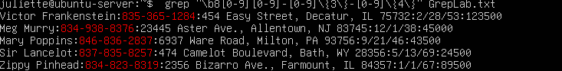
grep -oE "\b8[0-9]{2}-[0-9]{3}-[0-9]{4}" GrepLab.txt
How this command works
- grep → looks through the file line by line.
- -o → prints only the phone number, not the entire line.
- -E → allows us to use extra expressions like { } to control how many digits to match.
- \b → makes sure the match begins at the start of the number, not in the middle.
- 8[0-9]{2} → the area code:
  - 8 → the area code must start with 8.
  - [0-9] → means any digit from 0 to 9.
  - {2} → means exactly two digits.
  - Together → after the 8, there must be two more digits, making a 3-digit area code (e.g., 809, 892, 834).
- -[0-9]{3}- → the next part of the phone number:
  - - → the dash that separates parts of the number.
  - [0-9]{3} → means exactly three digits, such as 123, 456, or 987.
  - Another dash follows.
- [0-9]{4} → the final part of the phone number:
  - [0-9] → any digit.
  - {4} → exactly four digits, such as 5678, 0001, or 2345.
- GrepLab.txt → the file being searched.
Why it works (focusing on the numbers):
- Grep goes line by line and starts at the beginning of the number because of \b.
- 8[0-9]{2} ensures the area code is always three digits total and begins with 8 (e.g., 809, 892, 834).
- -[0-9]{3}-[0-9]{4} ensures the rest of the number is in the correct format — three digits, dash, four digits.
- [0-9] makes sure each position is a digit, not a letter or symbol.
- The {2}, {3}, and {4} tell grep to grab the exact number of digits in each part.
- Together, this guarantees grep prints only full phone numbers starting with 8, nothing extra.

- Print all lines containing an uppercase letter, followed by 4 lowercase letters, a space and one uppercase letter.
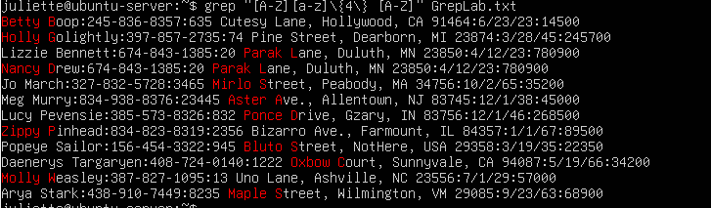
Command: grep -E "[A-Z][a-z]{4} [A-Z]" GrepLab.txt
How this command works:
- grep → looks through the file line by line to find matches.
- -E → stands for extra expressions, allowing us to use {} to specify exactly how many letters to match.
- [A-Z] → matches any single uppercase letter at the start of the pattern.
- [a-z]{4} → matches exactly four lowercase letters immediately after the uppercase letter.
- (space) → matches one space that comes after the four lowercase letters.
- [A-Z] → matches one uppercase letter immediately after that space.
- GrepLab.txt → the file being searched.
Why it works
- Grep scans each line to look for the pattern defined in the command.
- [A-Z][a-z]{4} ensures that the match starts with one uppercase letter followed by exactly four lowercase letters.
- The space () ensures that the next character after these four lowercase letters must be a space, so the match is precise.
- [A-Z] ensures that immediately after the space there is an uppercase letter.
- Together, this makes sure grep only prints lines that contain this exact pattern anywhere in the line, without matching anything that does not follow this combination of letters and space.

- Print lines where the address begins with a two- or three-digit number (so this would be 12 main st or 123 main street but not 1234 main street)
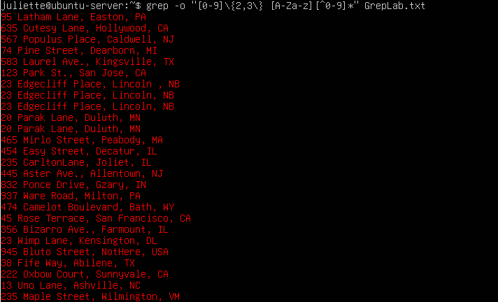
Command: grep -E "[0-9]\{2,3\} [A-Za-z][^0-9]*" GrepLab.txt
How this command: works
- grep → searches the file line by line.
- -E → stands for extra expressions, letting us use { } to specify exactly how many digits to match.
- [0-9]\{2,3\} → matches 2 or 3 digits, the starting number of the address.
  - [0-9] → any single digit from 0 to 9.
  - \{2,3\} → exactly 2 or 3 digits.
- (space) → matches the space immediately after the number, separating it from the street name.
- [A-Za-z] → matches the first letter of the street name, uppercase or lowercase.
- [^0-9]* → matches all characters that are not digits after the first letter.
  - This captures the rest of the street, city, and state.
  - It does not include the zip code, because zip codes have four or five digits, which come after the main address.
- GrepLab.txt → the file being searched.
Why it works (student-friendly, teachable):
- Grep looks at each line and finds a number that is 2 or 3 digits long at the start of the address part.
- The space ensures the number is separated from the street name, making the match precise.
- [A-Za-z] ensures the street name starts with a letter, which is standard in addresses.
- [^0-9]* captures the rest of the street, city, and state, ignoring the zip code, which has 4 or 5 digits.
- Together, the command prints the full address (without the zip code) that starts with a 2- or 3-digit number, which is exactly what the question asks.

- Print lines where the person lives in Mass or Illinois.
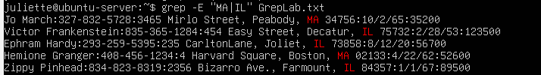
Command: grep -E "Mass|Illinois" GrepLab.txt
How this command works:
- grep → searches the file line by line to find matches.
- -E → stands for extra expressions, allowing us to use the | (OR) operator.
- Mass|Illinois → matches either “Mass” or “Illinois” in the line.
  - | → means OR, so grep will select lines containing either one of these words.
- GrepLab.txt → the file being searched.
Why it works (student-friendly, teachable):
- Grep goes line by line and checks for either of the two words.
- If a line contains “Mass”, it is selected.
- If a line contains “Illinois”, it is also selected.
- Together, this prints all lines where the location is either Mass or Illinois, which is exactly what the question asks.

- Print lines containing the addresses that aren’t on a street (You might see St as shorthand for street.
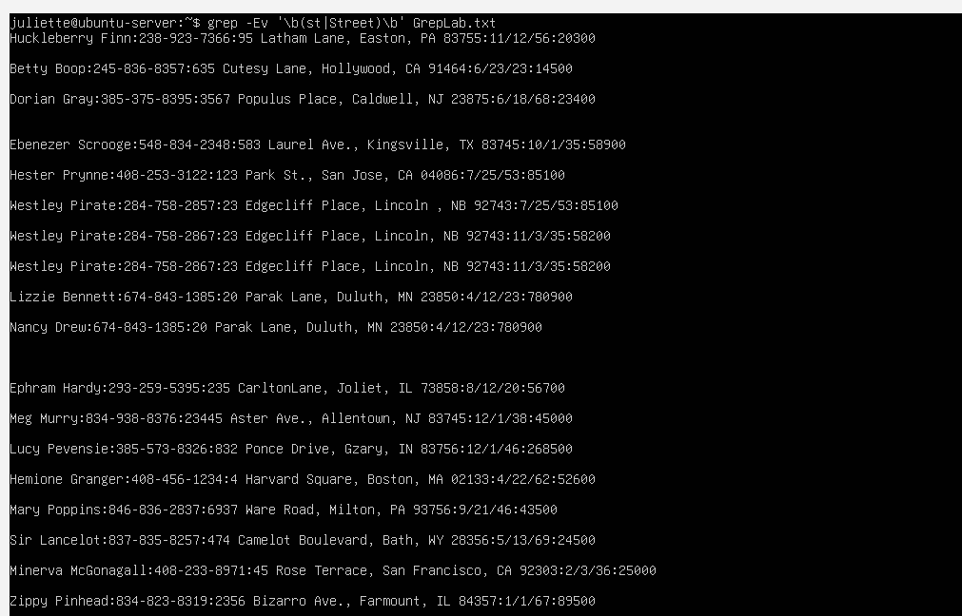
grep -Ev '\b(St|Street)\b' GrepLab.txt
How this command works:
- grep → checks each line in the file.
- -E → allows us to use parentheses and the OR operator (|).
- -v → flips the search, so instead of showing lines with “St” or “Street,” it shows only the lines without them.
- \b(St|Street)\b → this tells grep exactly what to look for:
  - (St|Street) → means match either “St” or “Street.”
  - \b → makes sure it matches whole words only, not parts of a name like Stoneham
Why this command works.
- The command scans every line of GrepLab.txt.
- If a line has “St” or “Street” as a complete word, grep recognizes it as a match.
- Because we used -v, those lines are left out of the results.
- The use of \b makes the command more accurate by making sure it only matches whole words. That means it will remove addresses like 123 Main St or 45 Oak Street, but it will not remove town names such as Stoneham or words like Wesley that just happen to contain the letters S and T.
- This way, the command only shows the addresses that are not on a street.

References:
GeeksforGeeks — https://www.geeksforgeeks.org/grep-command-in-unixlinux
YouTube video on grep basics — https://www.youtube.com/watch?v=VGgTmxXp7xQ

